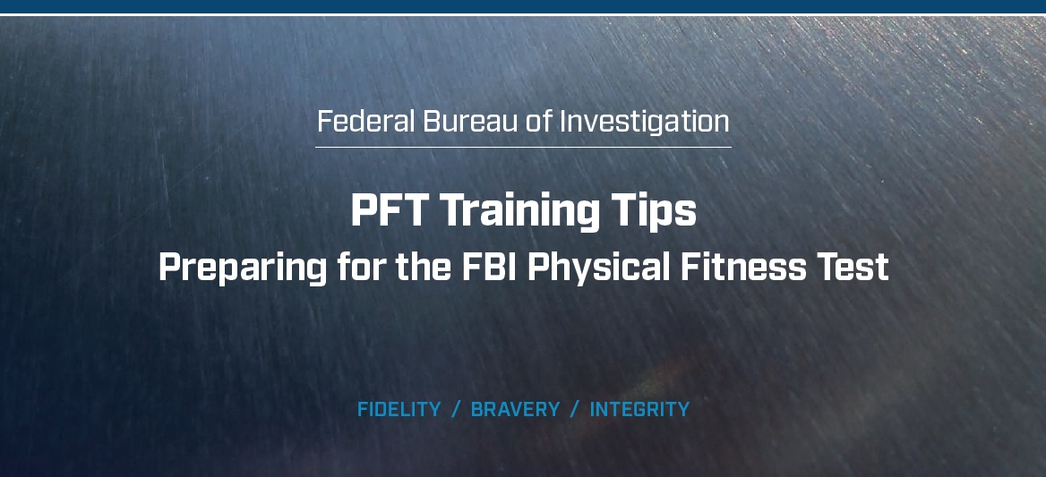

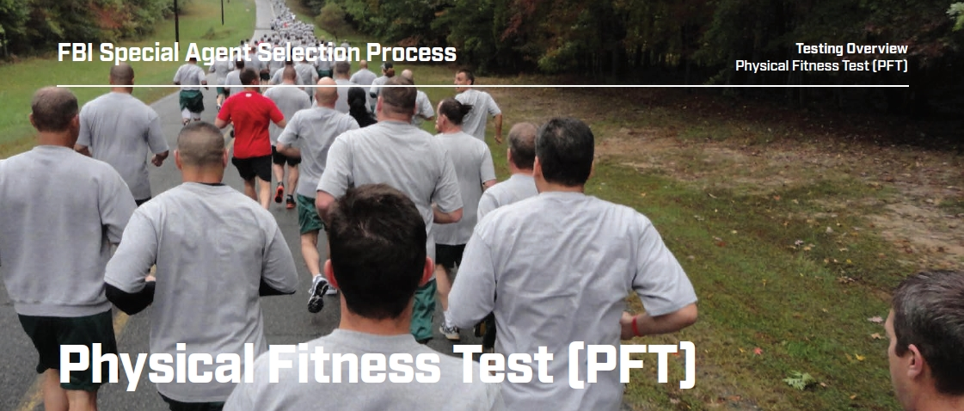

**Taking the Official PFT:**

The FBI Special Agent position requires a commitment to physical fitness as part of daily life. In addition to the self-administered PFT you took prior to submitting your Special Agent application, you will take an official standard PFT at least two times during the application period and/or at the FBI Academy. Specifically:

»» At your PFO shortly after passing Phase II.

»» No more than 120 days prior to reporting to the Basic Field Training Course (BFTC) at the FBI Academy. If an applicant is scheduled to report to a BFTC within 120 days of passing his or her post-Phase II PFT, an additional PFT is not required.

»» At least once while at the FBI Academy, during the first week of the BFTC.

The test, scoring scale and protocol are the same with an addition of the standard pullups event. The score on pullups is not used for pass/fail purposes but is considered for fitness awards at the Academy.

The standard PFT consists of four main events, with a fifth event for candidates in the Tactical Recruitment Program

(TRP). These events were chosen because they accurately measure an individual’s overall fitness level relative to the

essential tasks performed by FBI Special Agents. The events are administered in the following order with no more

than five minutes of rest in between each event:

1. Maximum number of continuous sit-ups in one minute.
2. Timed 300-meter sprint.
3. Maximum number of continuous push-ups (untimed).
4. Timed 1.5-mile run.
5. Maximum number of pullups (untimed).

Each event must be performed precisely according to the strictly defined protocol in order to be scored. In order to

pass the standard PFT, applicants must achieve a minimum cumulative score of 12 points in the first four events, with

at least one point in each of the first four events; therefore, it is possible for an applicant to receive a score of 12 (or

more) and still fail the standard PFT by failing one of the individual events. TRP applicants must achieve a minimum

score of 20 points and must score at least one point in each of the five events to pass the TRP PFT.

